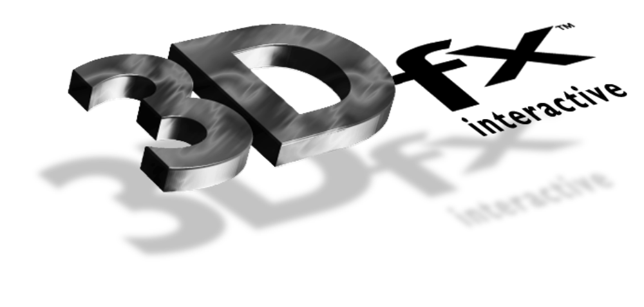

Release Notes

3Dfx Interactive Arcade Toolbox

ATB Version 0.4
31 January 1997
Copyright © 1995, 1996 3Dfx Interactive, Inc. All Rights Reserved

3Dfx Interactive, Inc.
415 Clyde Ave., Suite 105
Mountain View, CA 94043
Phone: (415) 934-2400
Fax: (415) 934-2424

Installation
Compilers
Compiling ATB Programs
Hardware Support
Obsidian™
Righteous 3D™
Operating Systems
DOS Notes
Windows95 Notes
Windows NT Notes
Demo Programs
Bugs
Bug Reporting
New with this release

Installation
Please see the document titled Installing and Using the Obsidian™ High Performance 3D Graphics Accelerator for installation instructions. Glide version 2.0b3 should have been installed previously.

Compilers
Supported Compilers Are:
- Microsoft® Visual C++ Version 2.2, 4.0, 4.1, 4.2 for Windows95 and Windows NT.
- Watcom C/C++ 10.6 for Windows 95, Windows NT, and DOS.

Compiling ATB Programs

Include And Library Files
The following header files are necessary to interface to each of the components of the Arcade Toolbox.
LIBRARY | HEADER | LIB
Utility | atutil.h | atu.lib
Math | atmath.h | atm.lib
Input | atinput.h | ati.lib
Rendering | atrender.h | atr.lib
Scene Management | atscene.h | ats.lib
GUI Utilities | atgui.h | atg.lib
Demo Utilities | atdemo.h | atd.lib
Multigen Loader | None | atcmg.lib
D3D Interface | None | atd3d.lib
Audio | ataudio.h | ata.lib

Path
On DOS, dos4gw.exe must be in your path. On Windows, sst1init.dll and glide.dll must be in your path.

Hardware Support
Glide and ATB support the following products:

Obsidian™
Glide 2.0b3 supports either one or two Texelfx chips (Amethyst™) . Further, it supports DACs from either ICS or AT&T.

Righteous 3D™ and Monster 3D™
This release of Glide supports the Righteous3D board from Orchid and Monster 3D from Diamond

SST-96.

Operating Systems
ATB supports Windows95, Windows NT and DOS. There is no native support in the development release for OS/2 or Linux.

DOS Notes
Glide, and therefore ATB, does not support the DOS/4GW Virtual Memory Manager(VMM) in stand-alone DOS shells.

Windows95 Notes
If you are running under Win95 and you have less than 24MB of RAM you must change your DOS properties settings. The value for DPMI memory must be changed from AUTO to 16384. The initial environment setting must also be changed from AUTO to a minimum of 4096 for some demos.

Windows NT Notes
Glide programs built for DOS4GW cannot be run under Windows NT.

Demo Programs
The following demos are present on the CD:
atsflip - a simple model viewer that allows you to load files in a number of different formats including 3D Studio, Alias RTG, MultiGen Open Flight.
fight - uses ATB to create a fighting demo that demonstrates many of the advanced features of the 3dfx hardware including: texture mapping, bilinear filtering, mip mapping, dynamic lighting, fog.
wiz - demonstrates the use of lighting maps to produce high quality textured environment’s. There are 5 rooms to explore. Wiz now supports fog.
flipper - an underwater demo that demonstrates geometric animation, advanced texture mapping (including projected textures), audio and the use of one or two TMU’s.
race - a racing demo that demonstrates the advanced rendering features (bilinear filtering, mip mapping, fog) provided by 3dfx hardware and the database loading, frustum culling and rendering provided by ATB.
demoroom: This demo was designed to show off multi-pass projected textures. The projected textures themselves consisted on mono color images, true color images, and animated images. Also shown in this demo are very high frequency textures -- showing off the importance of mip mapping and bilinear filtering.
Note: neither fight or wiz require any environment variables to be set to determine the location of their data files. If you set FIGHT_LOAD_PATH (or WIZ_LOAD_PATH) ensure that the fight.bof (wiz.bof) file is located in the specified search path. If these variables are not set the program assumes the data files are in the same directory as the executable (which is where the setup program installs them).
The program atsflip does use an environment (AT_LOAD_PATH) to determine where the files to be viewed are located. This variable is setup by the batch files provided in the flip directory. To view other files simply set this variable to the directories containing the files.
The environment variable SST_DUALHEAD can be used in all the demos to disable setting of the pass through mode when using two separate monitors (one for displaying windows and one for displaying the demo graphics).

Bugs

Bug Reporting
At this time ATB is provided in source code form on as-is basis and is NOT a supported product. If you have any questions or suggestions for enhancements please forward them via electronic mail to devsuppor@3dfx.com. Your comments will be reviewed and considered. 3Dfx Interactive does not guarantee that your questions will be answered nor your suggestions be included in future releases.

New with this release
The following features are new/changed in this release:
- Support for rendering via D3D to the 3DFX graphics hardware
- Multi pass fog
- More extensive image load support in the ATB rendering library
- Unified file search mechanism
- Better error detection and memory reallocation functions
To support these changes a number of enhancements have been necessary. The following changes should be made in source code using ATB in order to use the new libraries.

New devices/api’s supported
The call to atrInit has been changed to:
typedef void *AtrContext;

typedef struct {
void *hWnd;
FxBool emulation;
int refreshRate;
int numBuffers;
int smoothingMode;
void *info;
} AtrDriverInfo;

AtrContext atrInit( char *driverName, AtrDriverInfo *driverInfo);

The driver name should be one of: Glide, D3D or Rave (the name is case insensitive). The data structure AtrDriverInfo is used to configure the display. The hWnd variable is NULL for DOS or Glide and is used by D3D as the display window. The flag emulation specifies that a software only device should be used for rendering (again this is currently only used by D3D or Rave). The variable refreshRate specifies the desired monitor refresh rate. The numBuffers field is used to distinguish single and double buffering. The smoothingMode field requests video interpolation to smooth the final display image. The info field is driver specific and is currently not used. A typical initialization sequence (taken from the demo utility library) is:

_atGlobals.driverInfo.hWnd = _atGlobals.hWndMain;
_atGlobals.driverInfo.emulation = _atGlobals.emulation;
_atGlobals.driverInfo.refreshRate = GR_REFRESH_60Hz,
_atGlobals.driverInfo.numBuffers = 2; /* double buffer */
_atGlobals.driverInfo.smoothingMode = GR_SMOOTHING_ENABLE;
_atGlobals.driverInfo.info = NULL;

if ( (_atGlobals.ctx = atrInit( _atGlobals.driverName,
&_atGlobals.driverInfo) ) == NULL ) {
return FXFALSE;
}

The context argument returned represents the state of the device and should be none NULL if the initialization was successful.

To determine the characteristics of the initialized device call:

#define ATB_DEVICE_GLIDE 0
#define ATB_DEVICE_D3D 1

typedef struct {
FxU32 deviceType;
FxU32 pfxRev;
FxU32 pfxMem;
FxU32 numTex;
FxU32 tfxRev;
FxU32 tfxMem;
FxBool sli;
FxBool hasDepth;
FxBool fullScreen;
FxU32 width;
FxU32 height;
FxU32 bpp;
} AtrDriverCaps;

void atrQueryDriverCaps( AtrDriverCaps *caps );

This function replaces the old function:

void atrQueryVoodooCaps( AtrVoodooCaps *caps );

this structure describes the installed graphics subsystem its members are:

device - what kind of device are we driving
pfxRev - revision number of pixelFx chip
pfxMem - number of megabytes of framebuffer memory
numTex - number of texelFx chips available
tfxRev - revision number of texelFx chips
tfxMem - number of megabytes of texelFx memory
sli - true if SLI is enabled
texEntrySize - size of a texture entry in bytes
hasDepth - device has depth buffer
fullScreen - driver requires fullScreen operation
width - display width
height - display height
bpp - display depth

The function:

FxBool atrPause(FxBool flag);

Switches between VGA and 3DFX display modes (unless the environment variable SST_DUALHEAD is set.

The function:

FxBool atrBeginScene(FxU32 *viewWidth, FxU32 *viewHeight);

Should be called before setting any state or rendering any primitives associated with a frame. The arguments return the current width and height of the display surface.

The function:

FxBool atrEndScene(void);

Should be called after rendering all primitives in a frame and before calling atrSwapBuffer.

Since some devices and api’s don’t allow the passing of fog tables the environment data structure has been augmented by the fields:

AtrEnvFogFunction fogFunc;
float fogDensity
float fogNearW;
float fogFarW;

These fields are automatically setup by the call to atrEnvFogTable and so do not require an api change.

N.B. If you plan on being able to use ATB with drivers other than Glide make sure your code does NOT contain any direct calls to Glide, such calls will cause undetermined results (most likely some form of exception).

Image Loading

The function:

FxBool atrImgCreateFrom3df( AtrImg *i, const char *filename );

has been replace by:

FxBool atrImgCreateFromFile( AtrImg *i, const char *filename );

which in addition to loading 3df texture files also loads TGA, PPM formats and allows for future extension.

Multi Pass Fog

ATB now supports fog in multipass rendering. To use fog in multipass rendering set bit:

#define ATR_FOG_ON_DEPTH_MP 0x02

in the environment flags field and pass the bit:

ATR_MAT_FB_MULT_MP_FOG

to the function atrMaterialSetup for materials which require multiple passes.

The flags in the environment structure have been extended to add:

Chroma Keying

Support for chroma keying has been added and the following items have been added to the AtrMaterial structure:

FxBool chromaKeyEnable - FXTRUE if chromakey enabled
FxU32 chromakeyValue - chromakey value

Loaded texture statistics

The following field has been added to the AtrStats data structure:

FxU32 texBytesUsed[2];

This gives the total amount of memory (per TMU) which is used by all currently loaded textures that are associated with texture handles.

2D Rendering Functions

The following functions have been added to support 2D rendering:

void atrDrawPoint( const AtrDstVertex *p );

void atrDrawLine( const AtrDstVertex *a, const AtrDstVertex *b );

void atrDrawTriangle(const AtrDstVertex *a, const AtrDstVertex *b,
const AtrDstVertex *c);

It is assumed all lighting, transformation clipping operations have been performed on these vertices before calling the rendering functions.

Changes in the Input Library

The atiInit function has been changed to:

typedef void (* AtiMessageCB)(void);

FxBool atiInit(AtiMessageCB msgFunc);

The msgFunc performs any OS specific queuing of input data, under DOS this is a NOOP, under windows it is typically has the form:

void MessageFunc(void) {
MSG msg;

while (PeekMessage(&msg,NULL,0,0,PM_REMOVE)) {
TranslateMessage(&msg);
DispatchMessage(&msg);
}
}

The code in the demo utility directory gives examples of how the main or WinMain functions can be setup.

Changes in the Utility Library

The memory allocation functions now do a better job of checking for memory errors in debugging mode. A 4 byte buffer area is placed around each allocated area and filled with a distinctive pattern which can be used to check for overwriting memory areas. This checking can be controlled by calling:

void atuMemDebug(FxU32 flags);

If the flag ATU_MEM_CHECK is passed then checking is enabled, passing 0 will disable checking. If this flag is set the allocated memory areas are checked each time a memory allocation or deallocation function is called. The memory check can be performed explicitly by calling:

FxBool _atuMemCheck( char *where, FxU32 line );

A memory reallocation function:

void *atuMemRealloc( void *ptr, size )

has been added.

The functions:

void atrImgSetPath( const char *path );
void atsLoadPath(const char *load_path);

has been replaced by

void atuSetLoadPath(const char *load_path);

The related functions:

char * atuFileLocate(const char *filename, char *full_path);

Returns the full path name to the specified file: filename. While the function:

char *atuGetLoadPath(void);

returns the current search path.

